Activity description
Step 1: Provide information for listing on travel2change wordpress site*
Title  Give your activity a catchy title. | Sunset Gong Meditation  “A soothing mind massage”
Host name  Add “by Hostname in the tagline  Field” | by Jake Mussmann
Description  Describe the impact of your activity.  (Max. 400 characters) | Gong sound is a vacation for the mind, quiet refuge from our busy daily lives. Take in a beautiful Hawaiian sunset, then lay in nature surrounded by relaxing waves and calming vibrations.  Excellent for beginners, gong meditation is sometimes described as a “hard reset” for the mind; a bucket of ice-cold water to wake us up and enjoy life as it comes.  Sunset Gong Reviews:  “Sunset Gong Meditation helps me feel balanced, and more relaxed after each session. This activity helps greatly with stress management. ”— Janice Magdalena  “Always a great uplifting experience and the people you meet are awesome vibrations ”— Jeanette  “Wonderful first time gong meditation…Jake is an awesome instructor and would highly recommend his class.”— fdario  “Terrific! I will be back. Loved the experience. Thanks, Jake. ”— Luuk
Highlights  List what makes this activity unique.  (Bullet point list, max 400 characters) | Main benefits of gong meditation practice:  1) Reduce stress and anxiety  2) Increase self-confidence and attention  3) Empower positive cognitive change  4) Relieve insomnia  5) Improve dynamics between couples  6) Trigger and enhance one’s ability to dream  7) Promote increased empathy and compassion toward the self and others
Category  Select your category (Mauka/Makai/Maoli) | Not sure what this means
Meeting point - Google Map coordinates  Enter the address and the coordinates for the marker on Google Maps. | 21°17'04.2"N 157°50'47.7"W  21.284488, -157.846591
Images  We recommend using at least a 2160x1080px (2:1 ratio) image that's no larger than 10MB. | 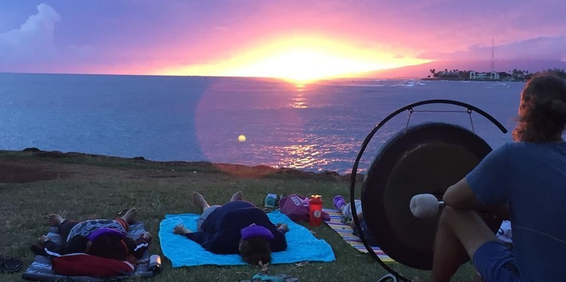
Step 2: Provide information for managing your activity on Fareharbor
Requirements (Item description)  List all the requirements that you expect from participants. Include what to bring and to wear. Specify what is not included. Enter this information into Item Description using this format:  #Requirements  [- Bullet 1]  [- Bullet 2] | What to bring:  - Please bring something comfortable to lie on: yoga mat/soft blanket/pillows  (whatever you need to best relax during our 75 minute meditation; each person has their own individual needs).  - Some people like to wrap themselves in a light cotton sheet, to prevent the possibility of ants disrupting their calm state.  - I will have a few extra yoga mats to use on a first come/first serve basis.
Item Confirmation Notes  Provides notes for people who have booked this activity. Remind participants what to bring, what time to arrive and how to find you.These notes are included in the receipt page, confirmation email, and reminder email. Use this format:  #Requirements  [Copy from above]  #Meeting time  [9 am]  #Meeting point  [Google map link]  [GOOGLE MAPS LINK](Insert short link here)  [Address]  [Description: Specify the exact meeting point and describe how participants will get there and find you. Add transportation options if applicable.]  #Contact  Jake Mussmann  808-673-0631  SunsetGong@gmail.com | What to bring:  - Please bring something comfortable to lie on: yoga mat/soft blacket/pillows  (whatever you need to best relax during our 75 minute meditation; each person has their own individual needs).  - Some people like to wrap themselves in a light cotton sheet, to prevent the possibility of ants disrupting their calm state.  - I will have a few extra yoga mats to use on a first come/first serve basis.  Meeting Time:  - Sunset is at 7:05pm, so it is recommended to arrive at least 10-15 minutes prior to settle in and enjoy the scene.  - Sound meditation begins at 7:15. If you arrive late, feel free to join us. But please find a spot quietly as not to disturb others.  - If driving, it is suggested to arrive by 6:30 to find parking in the Magic Island lot.  Meeting point:  - The group is located near the Banyan Tree on the tip of the Magic Island penninsula  - Look for the Sunset Gong Meditation Banner displayed on folding table.  - If you cannot find us, please call/text Jake at 808-673-0631  - Note: I will not answer texts/calls after 7:05pm, so please plan accordingly.
*The goal of the information on Wordpress is to get travelers to book.
**The goal for the information on Fareharbor is to give travelers all the details before booking (=Requirements) and after booking (=Item Confirmation Notes)
Testsite: http://wp-test.travel2change.org

